**Digital Marketing - Fundamentals of Digital Marketing**

**TomoWork Talent Accelerator Programme (TAP)**

**Introduction**

Welcome to the Digital Marketing Track! In the upcoming skills-based economy, industry recognised certifications play a pivotal role in representing the skills you have. In our TAP, all participants aim to complete at least two learning tracks. Below are the five learning tracks in TAP:

1. Financial Markets
2. Sustainability
3. Data Analytics
4. **Digital Marketing**
5. UI/UX Design
6. UIUX Design (Option 1)
7. Accessibility Design (Option 2)

**What is Digital Marketing?**

Digital Marketing is a form a marketing that uses electronic devices to convey promotional messaging and measure its impact. It typically refers to marketing campaigns that appear on a computer, tablet, or other device which can take many forms, such as display ads, search engine marketing and social media posts, allowing brands to connect with potential customers through the internet.

**Why Digital Marketing?**

Out of Singapore’s population (5.45 million), approximately 5.18 million are internet users[1]. 93% of internet users in Singapore access the internet for personal reasons every day and stay online for an average of 7.3 hours[2]. By taking advantage of the digital world, brands can attract more potential customers, keep existing customers up to date with their products and services, provide a great customer experience and more. To gain this important skillset, we have selected the *Google Fundamentals of Digital Marketing* as the certificate of choice.

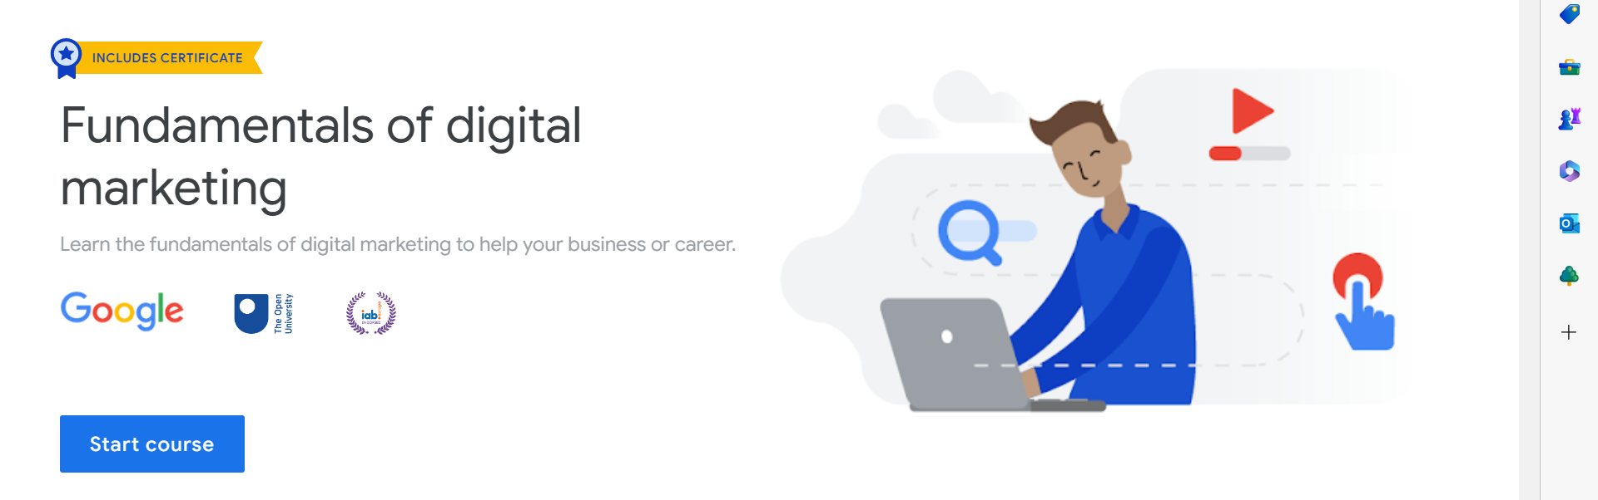

You will need to achieve this certificate during TAP in addition to another certificate from one of the other 5 learning tracks.

**Why this course?**

Google has been building products, platforms, and services that help people and businesses grow over the past 20 years. The courses are taught by google trainers and can be completed within 40 hours and are all 100% online.

**How do I earn a certificate of completion?**

All courses offer downloadable certificates upon completion of all requirements.

**What about the Fees?**

The course is free of charge. Should you encounter anything that requires payment, please consult your TAP Programme Director.

For any questions regarding your learning track, please ask your TAP Programme Director. Good luck on your learning Journey!

**TAP Co-Programme Directors**

Mr Mike Momota

E: [mike@tomowork.org](mailto:mike@tomowork.org)

Mr William Wong

E: [william@tomowork.org](mailto:william@tomowork.org)

1. “Topic: Internet Usage in Singapore.” Statista. Statista Research Department. Jan 3, 2023. <https://www.statista.com/topics/5852/internet-usage-in-singapore/#topicOverview>. Accessed Feb 28, 2023.
2. Ibid.